Third meeting for sprint 2 (Team 77)

## Meeting date | time Date | Time | Meeting location Location

## 09/10/18 2pm-3pm 1hr online-discord (link: http://duscird.gg/CeyTQc)

|  |  |  |  |  |  |  |  |
| --- | --- | --- | --- | --- | --- | --- | --- |
| |  |  | | --- | --- | | Meeting called by | Keonwoo Lee | | Note taker | Keonwoo Lee | | Timekeeper | Keonwoo Lee | | Attendees  Keonwoo Lee, Dipper Dai, Yiming Pan, Anqi Cui  Non-Attendees |

Discussion Conversation

The purpose of having today’s meeting is to check the progress of week 10’s sprint 2 activities done by each team member and to lay another plan for week11’s sprint 2 activities based on the retrospect.

**Further activities done**

* Story 25: History/Data manage (Load new data)
* Our original plan for story 24 was to have such functionality in the “History” menu but the function that helps load new data is now established in the “Record” menu
* The company user can now save new customer and order information into the database by filling up text fields

T**o do list for week11’s sprint 2 activities – focused on Story 11: Advertisement**

|  |  |  |
| --- | --- | --- |
| Action items | Person responsible | Deadline |
| **Topic 1** verify the story is complete (related to task ID T43) | Keonwoo Lee | 12/10/18 |
| **Topic 2** Add images for advertisements in the middle of the page and contact details in logos at the bottom of the webpage (related to task ID T38, T39) | Dipper Dai | 12/10/18 |
| **Topic 3** Create a prototype for the login page that has some advertisements including car images and the company’s brief contact details (related to task ID T37) | Yimming Pan | 12/10/18 |
| **Topic 4** Add code to enable the hyperlinks and write test cases (related to task ID T40, T43) | Anqi Cui | 12/10/18 |

**Special notes Type additional notes here**

* A creation of a Facebook page for the company can be considered
* A creation of a Twitter for the company can be considered

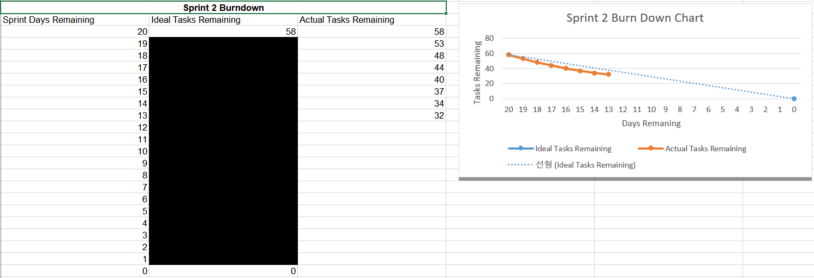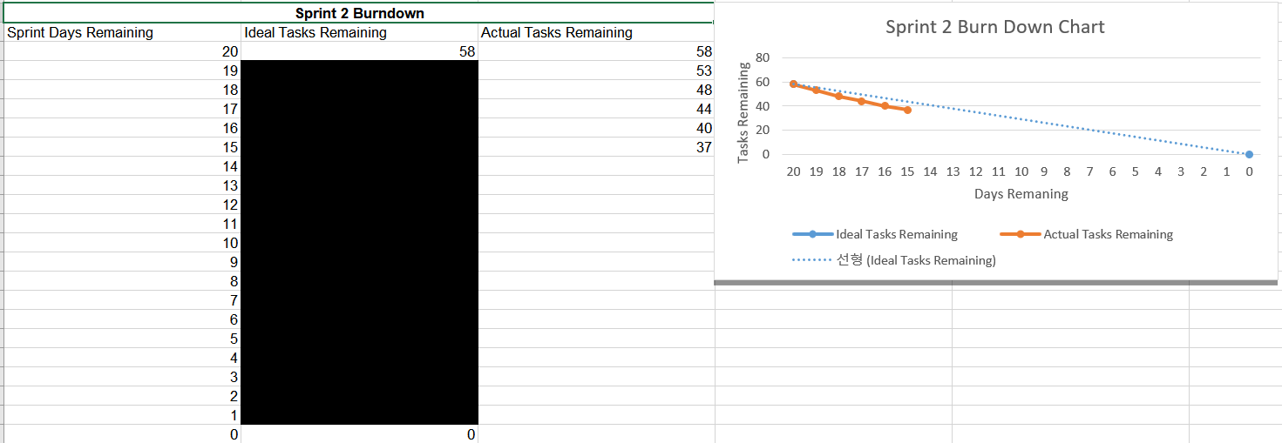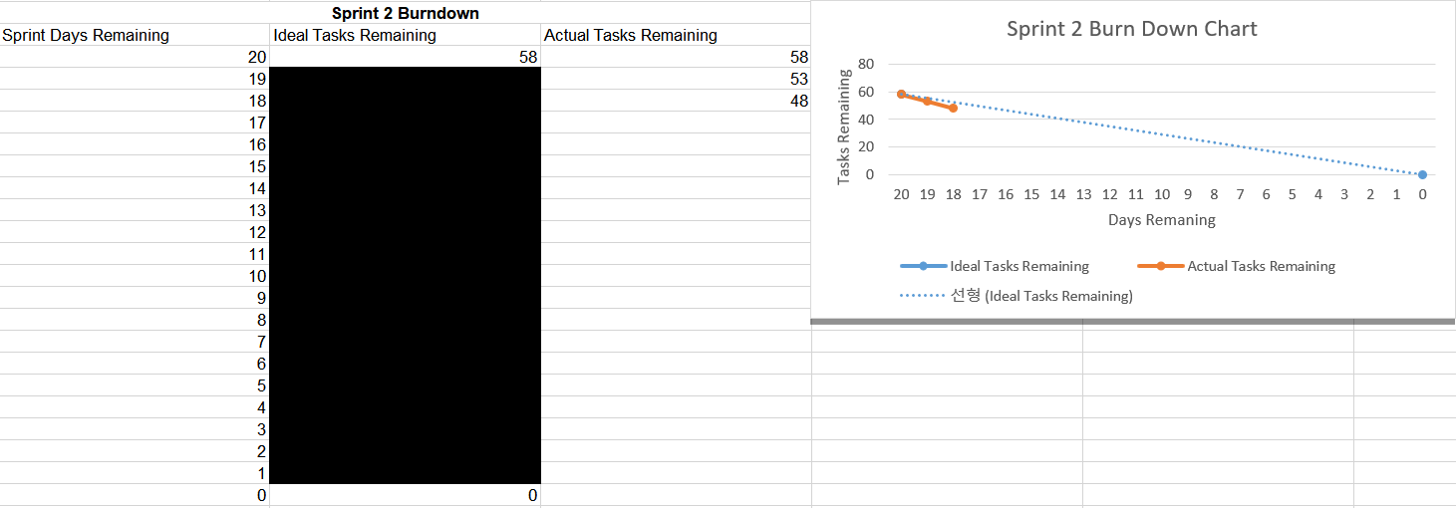**Burndown chart up to date**

**Next meeting:** To be negotiated during the Thursday’s workshop